UNIVERSITY OF CALGARY

Development and Evaluation of a Machine Learning-Based Image Classification Web Application for Mosquito Species Identification for Species Present in Alberta, Canada

by

Abdullah Zubair

A THESIS

SUBMITTED TO THE CUMMING SCHOOL OF MEDICINE

IN PARTIAL FULFILMENT OF THE REQUIREMENTS FOR THE

DEGREE OF BACHELOR OF HEALTH SCIENCES HONOURS

Bachelor of Health Sciences

Cumming School of Medicine

University of Calgary

Calgary, AB

March 2024

© Abdullah Zubair 2024

# Abstract

Mosquito-borne diseases pose significant public health challenges globally. Accurate species identification is crucial for effective mosquito control programs. This study aimed to develop a Convolutional Neural Network (CNN) model for automated identification of mosquito species in Alberta, Canada. A comprehensive image dataset was created by combining newly captured images of Alberta mosquitoes with existing published data. Transfer learning with a ResNet-50 architecture was employed to train, validate, and test the CNN model. Data augmentation, preprocessing techniques, and class imbalance mitigation strategies were applied. The best-performing model, identified through hyperparameter grid search, demonstrated high validation accuracy (91.78%), low validation loss (0.33), and strong average F1-score (90.37%). Our model was integrated into a user-friendly web application to facilitate rapid and accessible species identification. This research highlights the efficacy of machine learning for mosquito classification tasks and offers a valuable tool for public health initiatives, aiding in mosquito control programs. Future work could explore expanded datasets, alternative CNN architectures, and further refinement of class imbalance mitigation techniques to enhance our model's performance and generalizability.

# Acknowledgements

I would like to express my sincere gratitude to Dr. John Soghigian for the opportunity to conduct this thesis under his guidance and for his invaluable support throughout the process. His expertise and mentorship have been instrumental in shaping my research. I would also like to sincerely thank the entire lab team for their collaboration, assistance, and advice.

# Reflection

Throughout this past year working on this project, I have learned a substantial amount on the process and the effort it takes to conduct a large-scale thesis project. I have also learned quite a bit about myself and the best ways I like to go about learning various concepts. When I first started this project in September, I had little to no knowledge of machine learning or convolutional neural networks, which made it quite intimidating and challenging to get started. Initially, the plan was to modify or improve upon an existing published mosquito species identification model. Getting the existing model, I selected to work proved to be more difficult than anticipated and this led me to instead create my own model. Through this experience, I learned that while initially certain tasks may seem intimidating at first, breaking them down into smaller problems makes it easier to work on and less daunting. I was also able to learn that online resources are very abundant and good at explaining abstract concepts in an easy-to-understand manner. I was able to learn on my own using various online sources and videos and this was very motivating and what I would consider the best part of this project. I would say while I enjoyed most parts of this projects, having my code fail and then having to wait hours and often days to rerun and retrain the model on ARC was one of the more challenging aspects as it took up a significant amount of time. Overall, through conducting this project, self-learning, along with some of the courses I took during the semester, I was able to understand and learn quite thoroughly about machine learning, neural networks, and artificial intelligence. I chose this project because I wanted to focus on these fields and better understand them which I achieved. Moving forward, I want to apply the skills and knowledge gained from this experience to tackle new research challenges and specifically, I am hoping to pursue a master's degree related to machine learning and public health in the near future.

Table of Contents

Abstract ii

Acknowledgements iii

Reflection iv

1) Introduction 1

1.1) Mosquito Control Programs and Public Health 1

1.2) The Use of Machine Learning for Mosquito Species Identification 2

1.3) Overview of Previously Developed ML Models for Species Identification 3

2) Research Objective 5

2.1) Core Aims 5

2.2) Rationale and Consideration of Sex and Gender 5

3) Methods and Overview 6

3.1) Creation of Mosquito Image Dataset 6

3.2) Model Architecture 7

3.3) Loss Function 8

3.3) Data Augmentation and Preprocessing 8

3.4) Hyperparameter Optimization and Early Stopping 10

3.5) Model Training 10

3.6) Model Evaluation and Visualization 11

3.7) Web Application Development 12

5) Results and Discussion 13

6) Future Directions 18

7) Conclusion 19

8) Code and Dataset Availability 20

9) References 21

10) Appendices 24

10.1) Figures 24

10.2) Tables 36

**List of Figures**

* Figure 1. Illustration of Stratified Sampling for Maintaining Class Distribution Balance in the Original Dataset and the Sampled Subset.
* Figure 2. Flask Web Application Home Page
* Figure 3. Flask Web Application Showcasing Preview of Uploaded Image
* Figure 4. Flask Web Application Showcasing Multiple Image Upload Feature
* Figure 5. Flask Web Application Showcasing Results from Species Identification
* Figure 6. CPU Usage for CNN Model Creation on ARC Cluster
* Figure 7. GPU and GPU Memory Usage for CNN Model Creation on ARC Cluster
* Figure 8. Memory Usage for CNN Model Creation on ARC Cluster
* Figure 9. Comparison of Training and Validation Accuracy Among Various CNN Architectures with Varied Parameters: Learning Rate (lr), Batch Size (bs), and Optimizer (opt)
* Figure 10. Comparison of Training and Validation Loss Among Various CNN Architectures with Varied Parameters: Learning Rate (lr), Batch Size (bs), and Optimizer (opt)
* Figure 11. Comparison of Average F1 Score Among Various CNN Architectures with Varied Parameters: Learning Rate (lr), Batch Size (bs), and Optimizer (opt)
* Figure 12. F1 Score Per Species as a Function of the Number of Images of Each Species Present in our Image Dataset Using a Logarithmic Fit Based on our CNN Model with Learning Rate of 0.001, Batch Size of 16, and using the SGD Optimizer (lr=0.001_bs=16_opt=SGD)
* Figure 13. Normalized Confusion Matrix by Genus for CNN Model with Learning Rate of 0.001, Batch Size of 16, and using the SGD Optimizer (lr=0.001_bs=16_opt=SGD)
* Figure 14. Visualization of Gradient-weighted Class Activation Mappings (Grad-CAM) across Residual Blocks in our CNN Model with Learning Rate of 0.001, Batch Size of 16, and using the SGD Optimizer (lr=0.001_bs=16_opt=SGD) with a ResNet-50 Architecture for an image of a *Culex pipiens* specimen.

**List of Tables**

* Table 1. Number of Images Per Species Within the Captured Image Dataset
* Table 2. Number of Images Per Genus Within the Combined Mosquito Image Dataset
* Table 3. Number of Images Per Species Within the Combined Mosquito Image Dataset
* Table 4. Data Augmentation Techniques Used on the Training Subset of Images
* Table 5. Number of Mosquito Images Present within the Training, Validation, and Testing Subset and the Aggregate Total
* Table 6. Hyperparameter Grid Search Space for Mosquito Species Identification CNN Model
* Table 7. Resource Utilization and Runtime Analysis for CNN Model Creation on ARC Cluster

# 1) Introduction

Across the world, mosquitoes are a threat to public health where they occur (1,2). Belonging to the Culicidae family, mosquitoes serve are a vector for numerous deadly diseases, such as malaria, dengue fever, Zika fever, West Nile fever or encephalitis, and chikungunya (1,2). Mosquitoes are the primary vectors of these disease and are singlehandedly responsible for the transmission of them to millions of people worldwide, causing significant morbidity and mortality (1,3). The global burden of mosquito-borne diseases is substantial, with malaria alone causing an estimated 249 million cases and 608,000 deaths in 2022 (4). The impact of mosquitoes on human health extends beyond the direct effects of disease transmission, as the fear of contracting these illnesses can lead to reduced outdoor activities, decreased tourism, and other economic losses in affected regions (5-7).

## 1.1) Mosquito Control Programs and Public Health

Within Alberta, mosquito surveillance and control programs are present in both major cities, Calgary and Edmonton (8-10). Both cities have implemented comprehensive mosquito management strategies to monitor and mitigate the risks associated with these insects (8,10-12). These programs involve a multifaceted approach that includes mosquito population monitoring, larviciding, adulticiding, and public education initiatives (8,10-12). Specifically, both cities employ trained technicians that lay both carbon dioxide (CO2) traps as well as light traps in the summer to collect mosquito samples within respective city limits (8,10,11). The team then analyzes these samples to identify mosquito species composition, abundance, as well as the presence of potential disease-causing pathogens (10,11). This information is used to guide targeted control measures, such as the application of larvicides to water bodies where mosquito larvae develop and the selective use of adulticides to reduce adult mosquito populations when necessary (8,10,11). Additionally, both cities conduct public education campaigns to raise awareness about mosquito-borne diseases, promote personal protective measures, and encourage residents to eliminate mosquito breeding sites on their properties (8-12).

The primary mosquito-borne pathogen of concern in the province is West Nile virus, which was first detected in Alberta in 2003 (13). Since then, surveillance and control efforts have been essential in monitoring and managing the risk of West Nile virus transmission to humans (13,14). The detection of the invasive northern house mosquito, *Culex pipiens*, in Alberta has heightened concerns regarding the potential for this species to establish itself permanently, posing increased risks for vector-borne disease transmission (9,15). *Culex pipiens*, is a remarkably adaptable and opportunistic mosquito species as it thrives in a variety of environments, particularly human-modified habitats with standing water sources (16). This mosquito exhibits a preference for feeding on birds, making it a crucial player in the transmission cycle of avian-borne diseases such as West Nile (16). In 2018, *Culex pipiens* was first detected in Edmonton, and in the summer of 2022, it was found in Calgary for the first time by students in the Soghigian Lab at the University of Calgary (17). The introduction of this new invasive species highlights the critical importance of mosquito control programs. These efforts are vital not just to curb the spread of invasive species but also to mitigate the risk to public health (13,16,17).

## 1.2) The Use of Machine Learning for Mosquito Species Identification

Currently, the mosquito control programs in Alberta rely on manual identification methods, wherein trained personnel examine morphological characteristics of captured mosquitoes under a microscope and use morphological keys for identification (10,18). This process is time-consuming, labor-intensive, and dependent on the availability of skilled entomologists (10,18). As these manual identification methods rely on morphological features, computer vision and the use of machine learning (ML) algorithms present a scalable and potentially more accurate alternative. ML-based models specifically ones utilizing deep learning approaches such as convolutional neural networks (CNNs), excel at recognizing complex patterns within images. This makes these models ideal for analyzing the subtle variations in wing vein structures or body morphology that differentiate mosquito species (19). CNNs work by processing grid-like data, like images, by applying learnable filters to capture local patterns and features (20). CNN models consist of convolutional layers, which extract features, pooling layers that down sample the feature maps, and fully connected layers that combine the features to make predictions (20). Through training, the CNN learns the optimal values for the filters and weights, allowing it to automatically discover the most relevant features for the given task (20). Various CNN models have demonstrated notable accuracy in identifying mosquito species from images, greatly reducing the need for manual techniques, and enabling the processing of large volumes of data (21-24). The development of accurate and reliable ML models for mosquito species identification has the potential to transform mosquito surveillance and control programs by facilitating the early detection of invasive species and monitoring disease-carrying populations rapidly and on a larger scale than currently possible with manual techniques (21-24).

## 1.3) Overview of Previously Developed ML Models for Species Identification

Numerous studies have investigated the application of ML techniques for mosquito species identification, utilizing various model architecture, image datasets, and techniques (21-24). In one such study, Goodwin et al. developed a CNN-based approach for identifying mosquito species from a diverse image dataset of 2,696 specimens from 67 species, focusing primarily on wild-caught specimens (23). Their best-performing model, which used a Xception CNN architecture, achieved a 97.04% accuracy on a closed-set classification of 16 known species (23). When expanded to a wider closed-set of 39 species, the model achieved 93.6% accuracy and a macro F1-score of 85.07% (23). This study demonstrates the high accuracy of CNN models for accurate identification of mosquito species, even in the presence of morphologically similar species and damaged, wild-caught specimens (23). In a similar approach, Lee et al. developed a CNN-based image classification method for identifying eleven mosquito species inhabiting South Korea (24). They used a combination of color and fluorescence imaging of live mosquitoes to train various object detection models (24). The best-performing model, which combined a Swin Transformer and a Faster R-CNN architecture, achieved an F1-score of 97.1% (25).

Other similar studies have also resulted in reliable and accurate models with the use of a variety of different model architectures (18,21,22). Couret et al. created a novel image dataset of 1,709 images from 16 mosquito colonies, including 15 species, with a focus on malaria vectors in the genus Anopheles (21). After comparing multiple CNN architectures, a DenseNet-201 model was utilized and resulted in an accuracy of 96.96% (21). Furthermore, Okayasu et al, using a ResNet-18 architecture with data augmentation, achieved an accuracy of 95.5% with a dataset of three species of three different genera and over 14000 images (22). Finally, a study by Park et al. focused on a developing a CNN model to classify mosquito species with high inter-species similarity and intra-species variations (18). The study constructed a dataset of about 3,600 images of 8 mosquito species. Their best-performing model, using a VGG-16 architecture with fine-tuning and data augmentation, achieved an accuracy of 97.19% (18).

# 2) Research Objective



## 2.2) Rationale and Consideration of Sex and Gender

The development of a CNN model specifically tailored to the mosquito species present in Alberta could significantly benefit local mosquito control programs by enabling faster, less labor-intensive, and more accessible identification processes. Creating a comprehensive image dataset of Alberta's mosquito species, potentially combining it with existing datasets, would not only enhance our model's performance but also contribute to the broader research community, as large mosquito image datasets are currently scarce (23). Deploying the trained model through a simple and user-friendly web application would further increase its accessibility and adoption, particularly among mosquito control technicians who may have limited expertise in working with complex software. Additionally, sex and gender considerations are not applicable for this project as the focus is on developing a machine learning model for automated identification of mosquito species. The mosquito samples captured and imaged for the dataset are female.

# 3) Methods and Overview

## 3.1) Creation of Mosquito Image Dataset

Using mosquito samples procured through traps setup by the Soghigian lab in the summer of 2023 combined with contributions from the City of Calgary, we were able to obtain a diverse array of samples encompassing eight species across three genera (Table 1). We captured a total of 151 images using an iPhone 14 Pro Max mounted on a compound light microscope using a commercially available universal smartphone mount for microscopes. These images were then combined with the image dataset compiled by Goodwin et al., which was the most comprehensive dataset we could obtain, encompassing over 12,000 photos of 2,696 specimens from 67 species (23). While the Goodwin et al. dataset includes some species present in Alberta, utilizing a broader dataset that features a wider range of species is beneficial (23). Specifically, integrating our newly created dataset with the existing one from Goodwin et al., enhances our model’s accuracy in species identification, broaden its understanding of morphological variations within species, and improve its overall performance in classifying a wider range of mosquito species including ones found in Alberta (23). Furthermore, studies using CNNs indicate that transfer learning, as applied in our model, carries a risk of overfitting when working with smaller datasets meaning having a sufficiently large dataset is important (25, 26). Tables 2 and 3 provide a breakdown of the number of images by genera and species within the combined image dataset.

## 3.2) Model Architecture

For the basis of our mosquito species identification model, we opted to use a Residual Network (Res-Net) architecture (27). Specifically, we selected the ResNet-50 variant which consists of 50 layers, including convolutional layers, batch normalization layers, and activation functions (27). ResNet-50 was specifically chosen mainly due to its computational efficiency while having excellent performance in various image classification tasks (27,28). While Park et al. did observe VGG-16 having greater accuracy compared to ResNet-50 for mosquito species classification, this difference was minimal being only 0.33% (22). VGG-16 was, however, more computationally intensive due to its deeper architecture and larger number of parameters and this finding aligns with the comprehensive analysis of CNN architectures conducted by Canziani et al. (22,28). This study found that ResNet models consistently outperformed other architectures in terms of accuracy for image classification while requiring significantly fewer computational resources (28). Among the ResNet variants, deeper models such as ResNet-152 and ResNet-101 achieved only a slightly higher accuracy than ResNet-50 (28). However, this increased accuracy resulted in notably higher computational requirements and longer runtimes (28). With these factors considered, ResNet-50 was selected as the optimal choice (28).

The ResNet-50 model was initialized with pre-trained weights from the ImageNet-1K image dataset, a technique known as transfer learning (27,29,30). Transfer learning uses the knowledge gained by a given model on a large-scale dataset and adapts it to the specific task at hand, in our case mosquito species identification (29). By using pre-trained weights, a model can learn more effectively and converge faster, even with a limited amount of domain-specific data (29). The last fully connected layer of the ResNet-50 model was replaced with a new linear layer with its output size dynamically determined based on the number of mosquito species in the image dataset.

## 3.3) Loss Function

To optimize the performance of our model, we employed the cross-entropy loss function. This loss function is used for classification tasks, as it quantifies the difference between two probability distributions, the predicted probability distribution output by a given model, and the actual distribution of the labels (31). The Cross-Entropy Loss function effectively measures the performance of a model by penalizing deviations from the true label distributions, encouraging the model to output probabilities as close as possible to the actual labels (31). This mechanism is critical for ensuring that our model not only learns to classify mosquito species accurately but also refines its confidence in its predictions (31). The minimization of the Cross-Entropy Loss during training directly correlates with an increase in the accuracy and reliability of our model.

## 3.3) Data Augmentation and Preprocessing

The images were first scaled down to 224x224 pixels. This resizing was done as ResNet-50 is optimized for images at that resolution as the images in the ImageNet-1K dataset are at that resolution (27). Additionally resizing also has the added benefit of reducing the computational load of our model. Two separate data augmentation pipelines were then created. The training pipeline included various data augmentation techniques. Table 4 provides a thorough breakdown on the exact augmentation techniques used for the training pipeline. Data augmentation not only artificially expands the dataset by creating modified versions of existing images, but it helps a model learn invariant features and improves its generalization ability (32). By applying these transformations, our model was exposed to a wider range of variations in the training data, making it more resilient to changes in lighting, orientation, and scale (32). The testing pipeline, used on the validation and training subsets, only included resizing and normalization to maintain the integrity of the evaluation process.

The image dataset was split into static training, validation, and testing subsets using the scikit-learn library (33). The training subset was used to train our model, the validation subset was used to tune the hyperparameters and monitor our model's performance during training, and the testing subset was used to evaluate the final model's performance. The split ratios were chosen to ensure sufficient data for training while also having representative validation and testing subsets. A split ratio of 70% for training, 15% for validation, and 15% for testing was used to split the dataset and the exact numbers for each subset are shown in Table 5. When training, validating, and testing our model we needed to have a comprehensive representation across all genera and specifically a minimal inclusion of several images for each species within each phase of model development. Our dataset exhibits notable class imbalance, as shown in Table 2, which can lead to biased learning outcomes (34). This imbalance could not only undermine our model's overall accuracy, by impairing its ability to classify underrepresented classes, but also affects its generalizability to unseen data, especially for underrepresented classes (34). To remedy this imbalance, we utilized stratified sampling which is a method that ensures every species in a dataset is fairly represented across training, validation, and testing sets. This method works by dividing the images in the dataset into smaller, similar groups based on the species. Then, it randomly selects images from these groups while maintaining the original ratio of species present within the larger dataset. Figure 1 provides a visual illustration of this process. This method helps to prevent the issue of having some classes underrepresented or even missing in any of the subsets, making sure all classes are included.

## 3.4) Hyperparameter Optimization and Early Stopping

Hyperparameter optimization was implemented for our model. Specifically, a grid search approach was used. Grid search is a systematic way of exploring different combinations of hyperparameters to find the best-performing configuration (35). We optimized for batch size, learning rate as well as optimizer used (Table 6). Each combination of hyperparameters was evaluated using the validation subset, and the best-performing configuration was selected for the final model training. Our model was trained using the chosen hyperparameters for 150 epochs, however, early stopping was also implemented as a regularization technique to prevent overfitting (36). Early stopping monitors a model's performance on the validation subset and stops the training process if the performance does not improve for a predefined number of epochs, known as the patience (36). A patience value of 10 epochs was used. If the validation loss did not decrease for 10 consecutive epochs, the training was halted, and the model weights from the epoch with the lowest validation loss were saved for that permutation of the model.

## 3.5) Model Training

Our model was trained on the Advanced Research Computing (ARC) cluster with two Nvidia Tesla V100 16GB VRAM GPUs, 32 Xeon Gold 6148 cores, 64GB of memory, and a max time limit of 24 hours allocated (37). To optimize the utilization of computational resources, parallelization was also implemented which distributed the workload across the two GPUs. Due to the time limitations on utilizing the cluster, checkpointing was also implemented. This feature allowed for saving and loading model states at different stages of training, enabling the resumption of training from the last saved checkpoint in case of interruption. The checkpoints are saved based on the best validation loss achieved and a JSON file was used for tracking the progress of the training process. The JSON file stored information about the completed training configurations, along with their corresponding metrics such as validation loss, validation accuracy, training loss, training accuracy, and F1 scores.

## 3.6) Model Evaluation and Visualization

After conducting the grid search, the best model was selected based on a few metrics including validation loss, F1-score and accuracy. Validation loss is a metric used to assess how well a model performs on unseen data (31). For our model, we used cross-entropy loss as the loss function and as a result, the validation loss measures how well our model's predicted probabilities for each mosquito species match the true species labels of the images in the validation set (31). In other words, it quantifies the discrepancy between what our model predicts, and the actual species present in each validation image. By observing the validation loss, we were able to assess how well our model generalizes to new data and detect potential overfitting or underfitting (31). F1-score is another important metric we observed that provides a balanced measure of a model's performance, especially when dealing with imbalanced datasets (31). It is the harmonic mean of precision and recall, where precision measures the proportion of true positive predictions among all positive predictions, and recall measures the proportion of true positive predictions among all actual positive instances (31). A high F1-score indicates that a model has both high precision and high recall, meaning it can correctly identify mosquito species while minimizing false positives and false negatives (31). Finally, accuracy is the most straight-forward metric we observed as it provides an overall measure of a model's correctness in identifying mosquito species (31). It was important for us to have high accuracy to ensure reliable results and maintain confidence in our model's predictions.

Once our best model was found by mainly focusing on validation loss but also considering F1-score and accuracy, it was saved as a .pth file and it was then evaluated on the testing subset while observing multiple metrics which were computed using the scikit-learn library (33). These metrics were calculated for each mosquito species, as well as averaged across all species, to assess the model's overall performance. Matplotlib and seaborn libraries were utilized to generate plots of the various metrics of our models during the grid search (38,39). Furthermore, Gradient-weighted Class Activation Mapping (Grad-CAM) visualizations were also generated using the saved .pth file (40). Grad-CAM is a technique that highlights the regions of an input image that are most influential in a CNN model's prediction, visualizing what a CNN model is focusing on at different layers, providing insights into the model's decision-making process (40).

## 3.7) Web Application Development

To make the trained mosquito species identification model accessible, we also develop a web application using the Flask framework (41). Flask is a lightweight and versatile web framework for Python that allows for easy integration of machine learning models into web applications (41). The web application provides an intuitive interface for users to upload mosquito images and receive species identification results in real-time. The Flask application follows a client-server architecture, where the client-side handles user interactions and image uploads, while the server-side processes the uploaded images and generates identification results using the trained model. The application's front-end provides visually appealing user interface where users can select single or multiple mosquito images for identification as shown in Figure 2 and 3. A preview of the selected images is displayed before submission as shown in Figure 4. The identification result page presents the uploaded image alongside the predicted species and their confidence scores as shown in Figure 5. Users can then easily navigate back to the home page to perform additional identifications also shown in Figure 5.

On the server-side, the Flask application loads the trained ResNet-50 model. The model's weights are loaded from the .pth file saved earlier. The application also defines a label map that maps the model's output indices to their corresponding species names, enabling human-readable identification results. When a user uploads an image, the application saves the image file to a designated directory on the server. The image is then preprocessed using the same transformations applied during model training, including resizing, normalization, and conversion to a tensor format. The preprocessed image is passed through the loaded model, and the output probabilities are obtained using the SoftMax function. The top 5 predicted species and their corresponding probabilities are extracted and displayed to the user, along with the uploaded image. The Flask application also includes necessary error handling and file validation to ensure a smooth user experience. It checks for the presence of uploaded files and verifies that the file types are allowed (PNG or JPG/JPEG).

# 5) Results and Discussion

The process of creating our model on the ARC cluster took substantial computational resources (Table 7). In total the job ran for over 16 hours with the CPU time being almost 20 hours (Table 7). This runtime results in a 69.7% of the allocated time being used meaning the creation of our model was faster than expected (Table 7). The majority of the 32 CPU cores allocated were utilized with CPU utilization at 96.3% while memory and GPU utilization were lower at 34.5% and 20.4%. The CPU utilization was consistent throughout the entire runtime, while memory utilization seemed to increase linearly reaching a max of 38.58 GB being utilized (Figures 6,8). The GPU usage seemed to be very inconsistent while the GPU memory usage stayed around 5GB of VRAM used with one GPU having 16GB, this utilization is again low (Figure 7). The CPU utilization and this was likely due to the data preprocessing and transformations, splitting of the dataset, saving and loading checkpoints, progress tracking and saving progress in the JSON file, plotting and saving figures, evaluating and calculating metrics, as well as the print statements and logging operations. While the GPU is mainly used for the actual training and testing of a model. Overall, substantially less memory and only 1 GPU could have been allocated to create our model efficiently.

The results demonstrate that our model, when trained with various hyperparameter configurations, achieves high validation accuracy across most configurations (Figure 9). While the training accuracy was consistently high for all configurations, the validation accuracy provides a more reliable assessment of a model's performance on unseen data (Figure 9). The validation accuracy ranged from 72.34% to 91.78%, with the best-performing model configuration having a learning rate of 0.001, a batch size of 16, and utilizing the SGD optimizer (Figure 9). The overall high validation accuracy across all configurations suggests that the ResNet-50 architecture is well-suited for the task of mosquito species identification (Figure 9). The validation loss for each model configuration was also notably low, with the best-performing configuration (learning rate of 0.001, batch size of 16, and SGD optimizer) achieving a validation loss of 0.33 (Figure 10). Other configurations exhibited validation losses ranging from 0.35 to 0.98 (Figure 10). The consistently low training loss across all configurations indicates that the models were able to effectively learn from the image data (Figure 10). The average F1-scores for each model configuration followed a similar trend to the other evaluation metrics (Figure 11). The configuration with a learning rate of 0.001, a batch size of 16, and the SGD optimizer achieved the highest F1-score (Figure 11). Overall, the F1-scores ranged from 90.37% to 62.79%, demonstrating strong performance for most hyperparameter settings, with a few outliers exhibiting lower performance when measuring F1-ccore, which suggests higher false negative and false positive rates for those configurations.

These results highlight the importance of hyperparameter tuning in optimizing a model's performance. The learning rate, batch size, and choice of optimizer significantly impact a model's ability to learn discriminative features and generalize well to unseen data. Our best-performing model configuration, with a learning rate of 0.001, a batch size of 16, and the SGD optimizer, strikes a balance between convergence speed and generalization ability, enabling this model to achieve high validation accuracy, low validation loss, and a high F1-score (Figures 9,10,11). Additionally, the variability in performance across different hyperparameter settings also underscores the complexity of the mosquito species identification task. While the ResNet-50 architecture proves to be effective overall, the choice of hyperparameters can significantly influence the model's ability to distinguish between different species accurately. The lower performance of certain configurations, as indicated by their F1-scores, suggests that these settings may lead to higher rates of misclassification, emphasizing the need for careful hyperparameter tuning to minimize false negatives and false positives.

The normalized confusion matrix for our best-performing model highlights the classification performance across different mosquito genera (Figure 13). The matrix demonstrates that our model achieves high classification accuracy for the majority of the genera, with the highest accuracy observed for Aedes (0.97), Anopheles (0.97), Mansonia (1.00), and Uranotaenia (0.98) (Figure 13). These results indicate that our model has effectively learned distinctive features for these genera (Figure 13). However, it is important to note that the high accuracy for Uranotaenia could be attributed to the low number of images representing this genus within the dataset (Figure 13). Our model also exhibits excellent performance for *Coquillettidia* (0.96), Culex (0.96), and *Culiseta* (0.90), with only minor misclassifications among these genera (Figure 13). Specifically, a small number of instances are misclassified between closely related genera, such as a marginal confusion between *Coquillettidia* and *Aedes* (0.02 misclassified as *Aedes*) and between *Culex* and *Aedes* (0.02 misclassified as *Aedes*) (Figure 13). Our model's accuracy is slightly reduced for *Deinocerites*, with 88% (0.88) of instances correctly classified and a portion misclassified as *Culiseta* (0.09) (Figure 13). *Orthopodomyia* has an accuracy of 82% (0.82), with a notable confusion with *Psorophora* (0.27 misclassified as *Psorophora*) (Figure 13). This confusion suggests that our model may have difficulty distinguishing between the morphological features of *Orthopodomyia* and *Psorophora*, this could be attributed to the low number of images of the *Orthopodomyia* genus present within our dataset (Table 2). Remarkably, however, our model achieves perfect classification for *Mansonia* (1.00), reflecting its ability to identify highly specific features for this genus (Figure 13). The confusion matrix also indicates no significant systematic misclassifications or biases toward any specific genus, implying that our model has acquired a balanced understanding of the morphological features characteristic of each genus (Figure 13).

The F1-scores achieved by our best model exhibits a logarithmic correlation with the number of images available for each mosquito species in our dataset (Figure 12). As the number of images per species increases, the F1-score for a given species generally improves, with the best-performing model achieving high F1-scores for species with more than 100 images (Figure 12). This suggests that having a sufficient number of representative images is crucial for a model to learn the distinctive morphological features and intraspecific variations of each mosquito species. Notably, no species with more than 100 images produced an F1-score below 0.93, indicating that this threshold may serve as a rough estimate for the minimum number of images required to achieve reliable classification performance (Figure 12). However, numerous factors could impact this estimate, such as the complexity of the species' morphology, potential similarities to other species as well as the quality of the images in the dataset (Figure 12). The observed relationship between dataset size and classification accuracy overall highlights the importance of building a comprehensive and well-curated image databases for training species identification models. Furthermore, the similarity of this finding to that of Goodwin et al. reinforces the notion that data availability is a key factor in developing accurate CNN models for mosquito species identification, regardless of the specific architectures or techniques employed (23).

The progression of Grad-CAM visualizations across our model's residual blocks reveals a refinement in focus, transitioning from broad to more fine details (Figure 14). In the initial stages, our model primarily discerns the general morphology of the mosquito, prioritizing edges, and contours, which is evident from the broad distribution of the heatmap (Figure 14). As the model progresses to the subsequent block, its attention narrows, specifically targeting the wings and legs, as highlighted by the intensification of the heatmap in these regions (Figure 14). This suggests that our model has learned to recognize the importance of these features in distinguishing between different mosquito species (Figure 14). Continuing onto the later blocks, the model's focus becomes increasingly targeted, with the heatmap prominently marking the abdomen while also considering the legs and to lesser extent the wings (Figure 14). This focus suggests that our model has developed a recognition of critical discriminative features, which allows it to accurately distinguish between species based on subtle morphological differences (Figure 14). Overall, the Grad-CAM visualizations provide valuable insights as by observing the progression of the heatmaps across the residual blocks, we can better understand how the model gradually refines its focus and learns to prioritize the most informative features for species classification (Figure 14).

# 6) Future Directions

While our model demonstrated excellent performance based on the several key metrics, improvements could still be explored to further enhance its capabilities. One straightforward avenue to investigate is the use of deeper ResNet architectures, such as ResNet-101 or ResNet-152, which have shown superior performance in various image classification tasks compared to ResNet-50 (27,28). These deeper architectures can learn more complex and discriminative features, potentially leading to better species identification accuracy, given sufficient computational resources and time which, as shown by our model’s low GPU utilization, ARC has the capability to support (27,28). Another promising direction is to explore alternative CNN architectures, such as ResNeXt, which aims to improve upon ResNet (3). ResNeXt has demonstrated impressive performance on several image classification benchmarks while maintaining a computational cost similar to ResNet (42). Incorporating ResNeXt would be a logical next step in attempting to improving our model.

To provide a more robust evaluation of the model's performance and reduce the risk of overfitting, cross-validation techniques, such as k-fold cross-validation, could be implemented instead of a single train/validate/test split (35). Cross-validation assesses how well the model generalizes to unseen data by training and testing the model on multiple subsets of the dataset (35). Furthermore, utilizing more advanced hyperparameter optimization methods, such as Bayesian optimization or random search, could lead to the discovery of better hyperparameter configurations compared to grid search (43,44). These methods can more efficiently search the hyperparameter space and identify optimal combinations that further improve the model's performance (43,44). Additionally, to better address the class imbalance problem within our image dataset, the use of focal loss as an alternative to cross-entropy loss could be implemented (45). Focal loss is designed to focus on hard-to-classify examples and down-weight the contribution of easy examples during training, which can help the model learn more effectively from underrepresented classes (45).

Improving the quality of the collected mosquito samples is another crucial aspect to consider. Samples that are less damaged or broken can provide more accurate morphological information for species identification (23). As our samples were collected in the summer it meant they were several months old which led to fragile samples that were easily damaged leading to less-than-ideal images. While our lab did have a reasonable number of species and mosquito samples available, expanding the dataset to include a wider range of mosquito species found within Alberta would make our model more comprehensive and potentially a useful asset for mosquito control programs across Alberta.

# 7) Conclusion

This projects aim was to develop a CNN model for automated identification of mosquito species prevalent in Alberta, Canada. A comprehensive image dataset was created through the combination of newly captured Alberta mosquito images and existing published data. Employing a ResNet-50 architecture and transfer learning, the CNN model was carefully trained, validated, and tested, utilizing data augmentation, preprocessing, and addressing class imbalance. Hyperparameter grid search identified the best-performing model, demonstrating high validation accuracy, low validation loss, and strong F1-scores across genera. Our model's integration into a user-friendly web application facilitates rapid and accessible species identification, aiding mosquito control programs. This work highlights the efficacy of deep learning for challenging insect classification tasks, offering a valuable tool for public health initiatives and demonstrating potential for further refinement through expanded datasets, alternative CNN architectures, or class imbalance mitigation techniques.

# 8) Code and Dataset Availability

The code used to create the model, run the app, as well as the captured image dataset are available on GitHub: <https://github.com/AHZR199/Mosquito-Species-Identification-Model>.

# 9) References

1. World Health Organization. Vector-borne diseases [Internet]. 2021 [cited 2023 Mar 11]. Available from: <https://www.who.int/news-room/fact-sheets/detail/vector-borne-diseases>
2. Tolle MA. Mosquito-borne diseases. Curr Probl Pediatr Adolesc Health Care. 2009 Apr;39(4):97–140.
3. Bhatt S, Gething PW, Brady OJ, Messina JP, Farlow AW, Moyes CL, et al. The global distribution and burden of dengue. Nature. 2013 Apr;496(7446):504–507.
4. World Health Organization. World malaria report 2023 [Internet]. 2020 [cited 2023 Mar 11]. Available from: <https://www.who.int/publications/i/item/9789240086173>
5. Shepard DS, Undurraga EA, Halasa YA, Stanaway JD. The global economic burden of dengue: a systematic analysis. Lancet Infect Dis. 2016 Aug;16(8):935-41.
6. Pan Y, Cai W, Pan Y. Tourism and the fear of Zika virus: Evidence from travel search behavior. Tour Econ. 2019;25(4):674-687.
7. Roehrig JT. The economic impact of mosquito-borne disease in the United States. PLoS Negl Trop Dis. 2017;11(8):e0005762.
8. City of Calgary. Mosquitoes in Calgary [Internet]. Calgary: City of Calgary; [date unknown] [cited 2023 Mar 11]. Available from: <https://www.calgary.ca/parks/pests/mosquitoes.html>
9. City of Edmonton. Mosquitoes [Internet]. Edmonton: City of Edmonton; [date unknown] [cited 2023 Mar 11]. Available from: <https://www.edmonton.ca/programs_services/pests/mosquitoes>
10. Coker A. Integrated Pest Management Technician, City of Calgary. Personal communication; 2023.
11. City of Edmonton. Edmonton's mosquito control program [Internet]. Edmonton: City of Edmonton; [date unknown] [cited 2024 Mar 11]. Available from: <https://www.edmonton.ca/programs_services/pests/edmontons-mosquito-control-program>
12. City of Edmonton. Mosquito pest controls [Internet]. Edmonton: City of Edmonton; [date unknown] [cited 2024 Mar 11]. Available from: <https://www.edmonton.ca/city_government/environmental_stewardship/mosquito-pest-controls>
13. Government of Alberta. West Nile virus and surveillance [Internet]. Edmonton: Government of Alberta; [updated 2024 Mar 12; cited 2024 Mar 11]. Available from: <https://www.alberta.ca/west-nile-virus-surveillance>
14. City of Edmonton. West Nile virus in Edmonton [Internet]. Edmonton: City of Edmonton; [date unknown] [cited 2024 Mar 11]. Available from: <https://www.edmonton.ca/programs_services/pests/west-nile-virus-in-edmonton>
15. Siegers K. The urban mosquito is thriving farther north than it's ever been, and scientists are worried [Internet]. Toronto: CBC News; 2023 Jul 15 [updated 2023 Jul 17; cited 2024 Mar 11]. Available from: <https://www.cbc.ca/news/canada/edmonton/urban-mosquitoes-1.6906328>
16. Farajollahi A, Fonseca DM, Kramer LD, Kilpatrick AM. "Bird biting" mosquitoes and human disease: A review of the role of Culex pipiens complex mosquitoes in epidemiology. Infect Genet Evol. 2011 Oct; 11(7):1577-85.
17. Glowa Kobe K. Invasive mosquito that can carry West Nile virus detected in Calgary and Edmonton [Internet]. Calgary: University of Calgary; 2023 Jul 26 [cited 2024 Mar 11]. Available from: <https://ucalgary.ca/news/invasive-mosquito-can-carry-west-nile-virus-detected-calgary-and-edmonton>
18. Park J, Kim DI, Choi B, Kang W, Kwon HW. Classification and Morphological Analysis of Vector Mosquitoes using Deep Convolutional Neural Networks. Sci Rep. 2020 Jan 16;10(1):1012.
19. LeCun Y, Bengio Y, Hinton G. Deep learning. Nature. 2015 May;521(7553):436-44.
20. Goodfellow I, Bengio Y, Courville A. Deep Learning. Cambridge, MA: MIT Press; 2016.
21. Couret J, Dotson EM, Benedict MQ.  Delimiting cryptic morphological variation among human malaria vector species using convolutional neural networks. PLoS Negl Trop Dis. 2020;14(12): e0008904.
22. Okayasu K, Yoshida K, Fuchida M, Nakamura A. Vision-based classification of mosquito species: Comparison of conventional and deep learning methods. Appl Sci. 2019; 9(18): 3935.
23. Goodwin A, et al. Mosquito species identification using convolutional neural networks with a multitiered ensemble model for novel species detection. Sci Rep. 2021;11(1):13656.
24. Lee S, Kim H, Cho BK. Deep learning-based image classification for major mosquito species inhabiting Korea. Insects. 2023 Jun 5;14(6):526.
25. Dawson HL, Dubrule O, John CM. Impact of dataset size and convolutional neural network architecture on transfer learning for carbonate rock classification. Comput Geosci. 2023 Feb 1;171:105284.
26. Romero M, Interian Y, Solberg T, Valdes G. Targeted transfer learning to improve performance in small medical physics datasets. Medical physics. 2020 Dec;47(12):6246-56.
27. He K, Zhang X, Ren S, Sun J. Deep residual learning for image recognition. InProceedings of the IEEE conference on computer vision and pattern recognition 2016 (pp. 770-778).
28. Canziani A, Paszke A, Culurciello E. An analysis of deep neural network models for practical applications. arXiv preprint arXiv:1605.07678. 2016 May 24.
29. Yosinski J, Clune J, Bengio Y, Lipson H. How transferable are features in deep neural networks?. Advances in neural information processing systems. 2014;27.
30. Russakovsky O, Deng J, Su H, Krause J, Satheesh S, Ma S, Huang Z, Karpathy A, Khosla A, Bernstein M, Berg AC. Imagenet large scale visual recognition challenge. International journal of computer vision. 2015 Dec;115:211-52.
31. Goodfellow I, Bengio Y, Courville A. Deep learning. MIT press; 2016 Nov 10.
32. Shorten C, Khoshgoftaar TM. A survey on image data augmentation for deep learning. Journal of big data. 2019 Dec;6(1):1-48.
33. Pedregosa F, Varoquaux G, Gramfort A, Michel V, Thirion B, Grisel O, Blondel M, Prettenhofer P, Weiss R, Dubourg V, Vanderplas J. Scikit-learn: Machine learning in Python. the Journal of machine Learning research. 2011 Nov 1;12:2825-30.
34. Oksuz K, Cam BC, Kalkan S, Akbas E. Imbalance problems in object detection: A review. IEEE transactions on pattern analysis and machine intelligence. 2020 Mar 19;43(10):3388-415.
35. Müller AC, Guido S. Introduction to machine learning with Python: a guide for data scientists. " O'Reilly Media, Inc."; 2016 Sep 26.
36. Prechelt L. Early stopping-but when?. InNeural Networks: Tricks of the trade 2002 Mar 28 (pp. 55-69). Berlin, Heidelberg: Springer Berlin Heidelberg.
37. ARC Cluster Guide [Internet]. Calgary: University of Calgary; [cited 2024 Mar 16]. Available from: <https://rcs.ucalgary.ca/ARC_Cluster_Guide>
38. Barrett P, Hunter J, Miller JT, Hsu JC, Greenfield P. matplotlib--A Portable Python Plotting Package. InAstronomical data analysis software and systems XIV 2005 Dec (Vol. 347, p. 91).
39. Seaborn Development Team. 2021. Statistical Data Visualization. Seaborn. [online] Available at: <https://seaborn.pydata.org/> [Accessed 16 March 2024].
40. Selvaraju, R.R., Cogswell, M., Das, A., Vedantam, R., Parikh, D. and Batra, D., 2017. Grad-CAM: Visual Explanations from Deep Networks via Gradient-based Localization. In: Proceedings of the IEEE International Conference on Computer Vision. [online] Available at: <https://openaccess.thecvf.com/content_iccv_2017/html/Selvaraju_Grad-CAM_Visual_Explanations_ICCV_2017_paper.html> [Accessed 16 March 2024].
41. Grinberg M. Flask web development. " O'Reilly Media, Inc."; 2018 Mar 5.
42. Xie S, Girshick R, Dollár P, Tu Z, He K. Aggregated residual transformations for deep neural networks. InProceedings of the IEEE conference on computer vision and pattern recognition 2017 (pp. 1492-1500).
43. Snoek J, Larochelle H, Adams RP. Practical bayesian optimization of machine learning algorithms. Advances in neural information processing systems. 2012;25.
44. Bergstra J, Bengio Y. Random search for hyper-parameter optimization. Journal of machine learning research. 2012;13(2).
45. Lin TY, Goyal P, Girshick R, He K, Dollár P. Focal loss for dense object detection. In: Proceedings of the IEEE international conference on computer vision. 2017. p. 2980–8.

# 10) Appendices

## 10.1) Figures

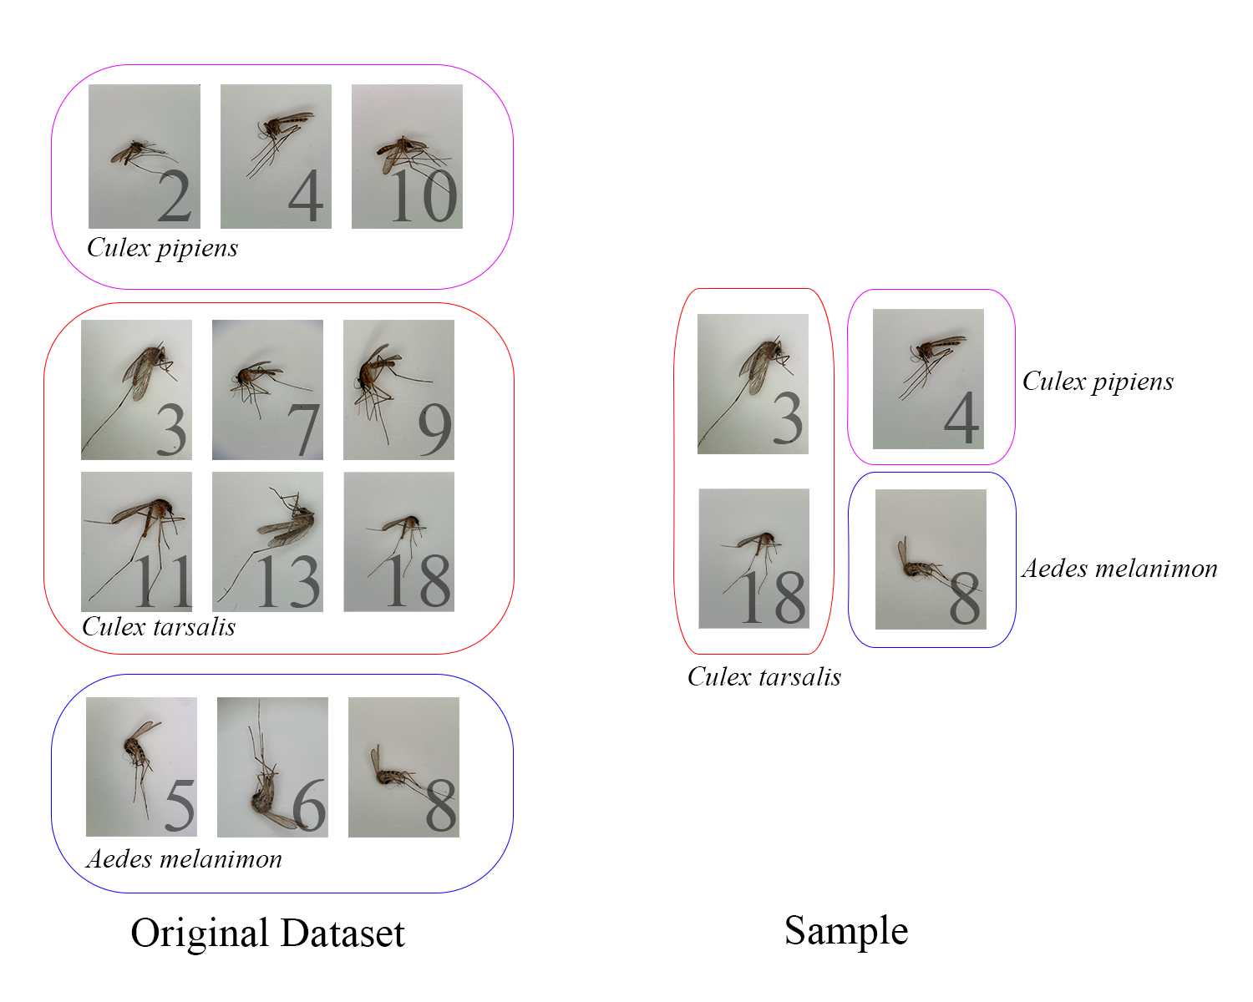

Figure 1. Illustration of Stratified Sampling for Maintaining Class Distribution Balance in the Original Dataset and the Sampled Subset.

The original dataset consists of three mosquito species: *Culex pipiens*, *Culex tarsalis*, and *Aedes melanimon*. Stratified sampling ensures that the proportion of each species is preserved in the resulting sample, as evident from the selected images for each class.

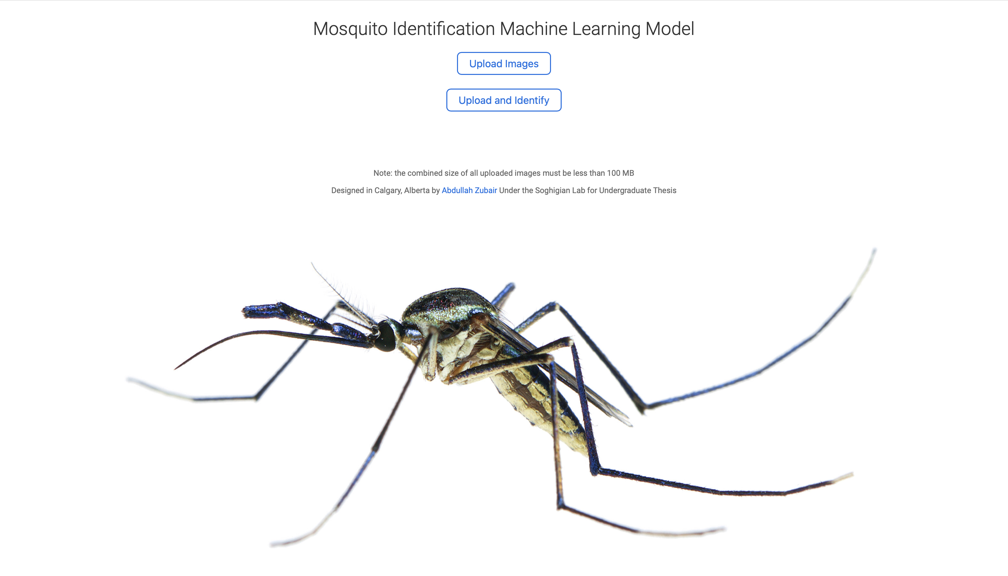

Figure 2. Flask Web Application Home Page

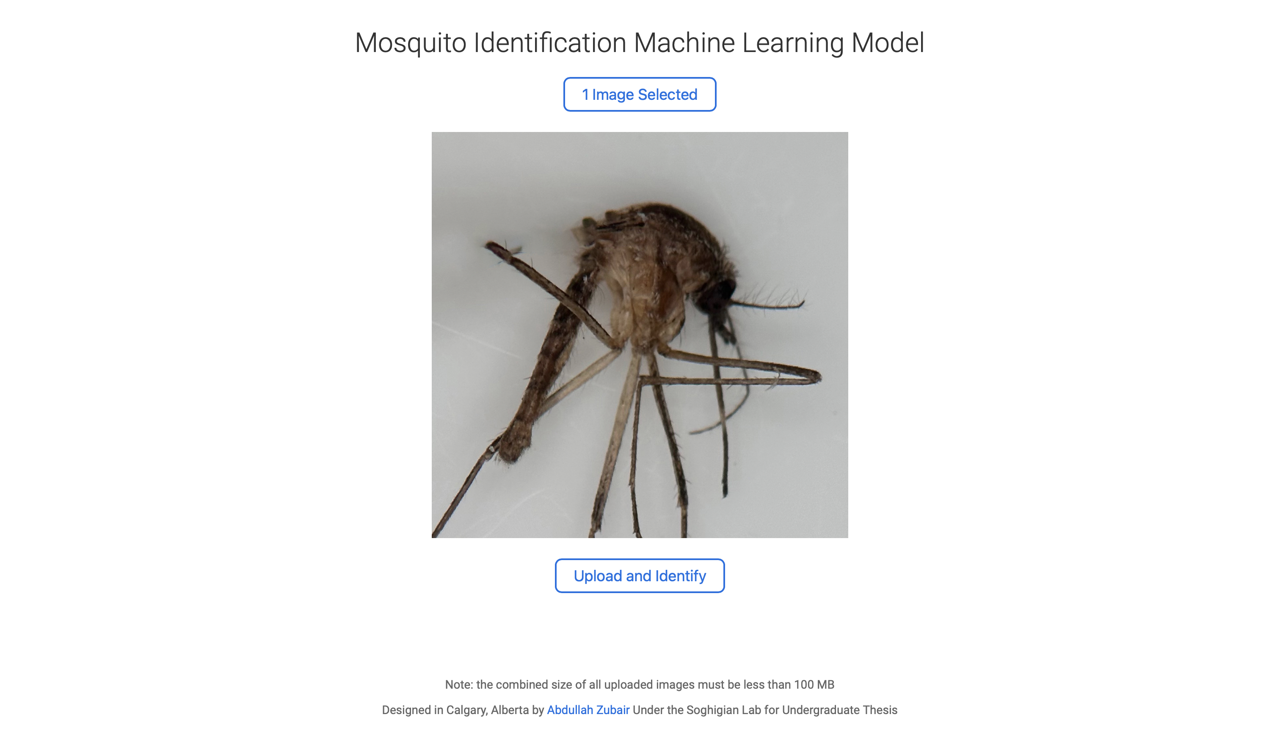

Figure 3. Flask Web Application Showcasing Preview of Uploaded Image

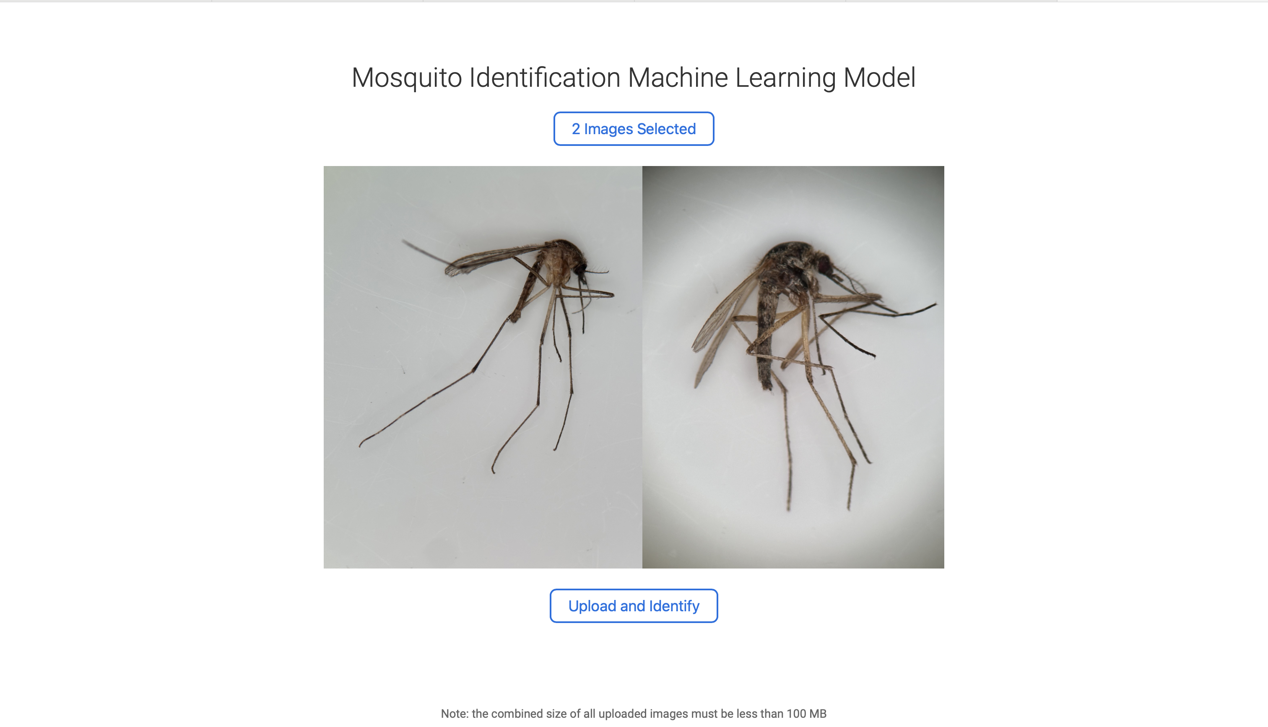

Figure 4. Flask Web Application Showcasing Multiple Image Upload Feature

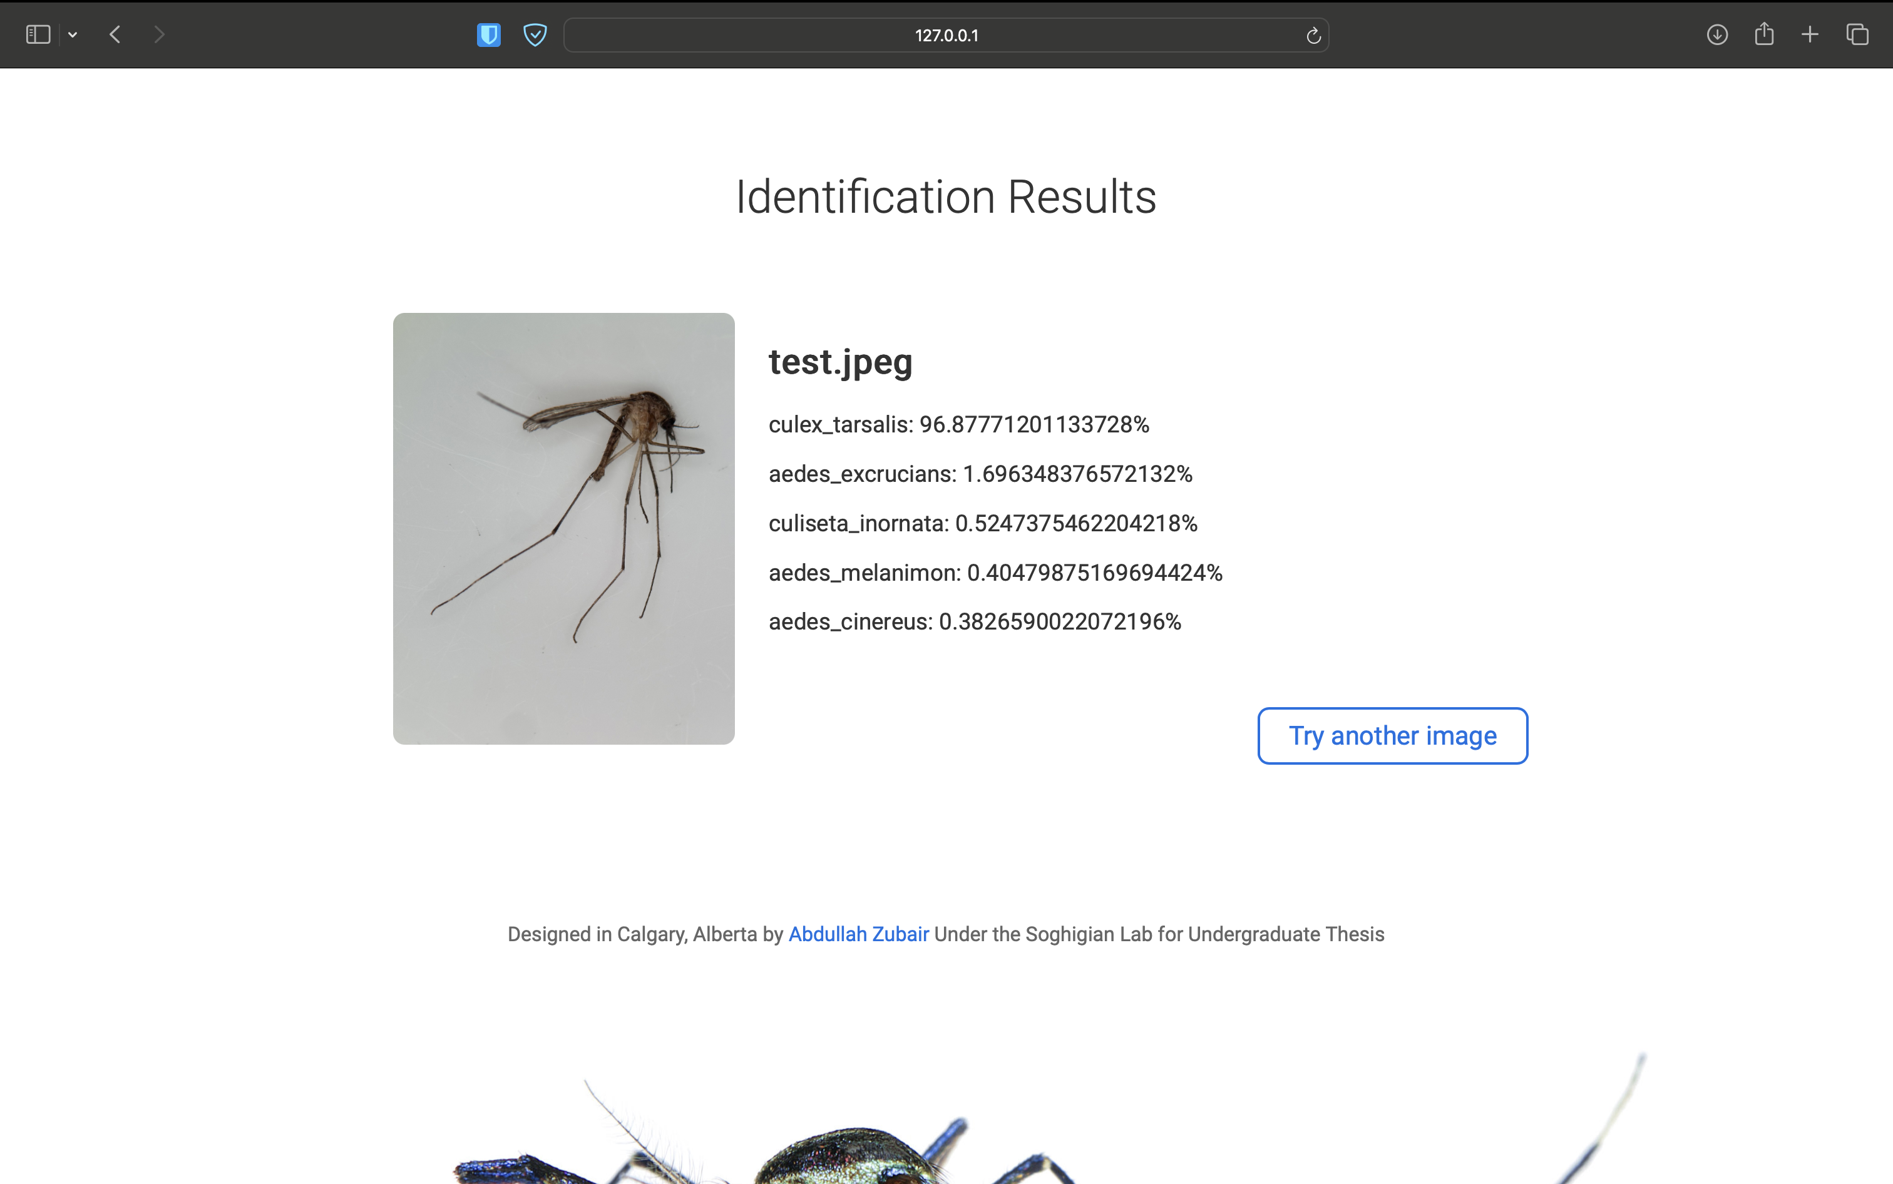

Figure 5. Flask Web Application Showcasing Results from Species Identification. Example Image shown is of a *Culex tarsalis* specimen which the application correctly identifies.

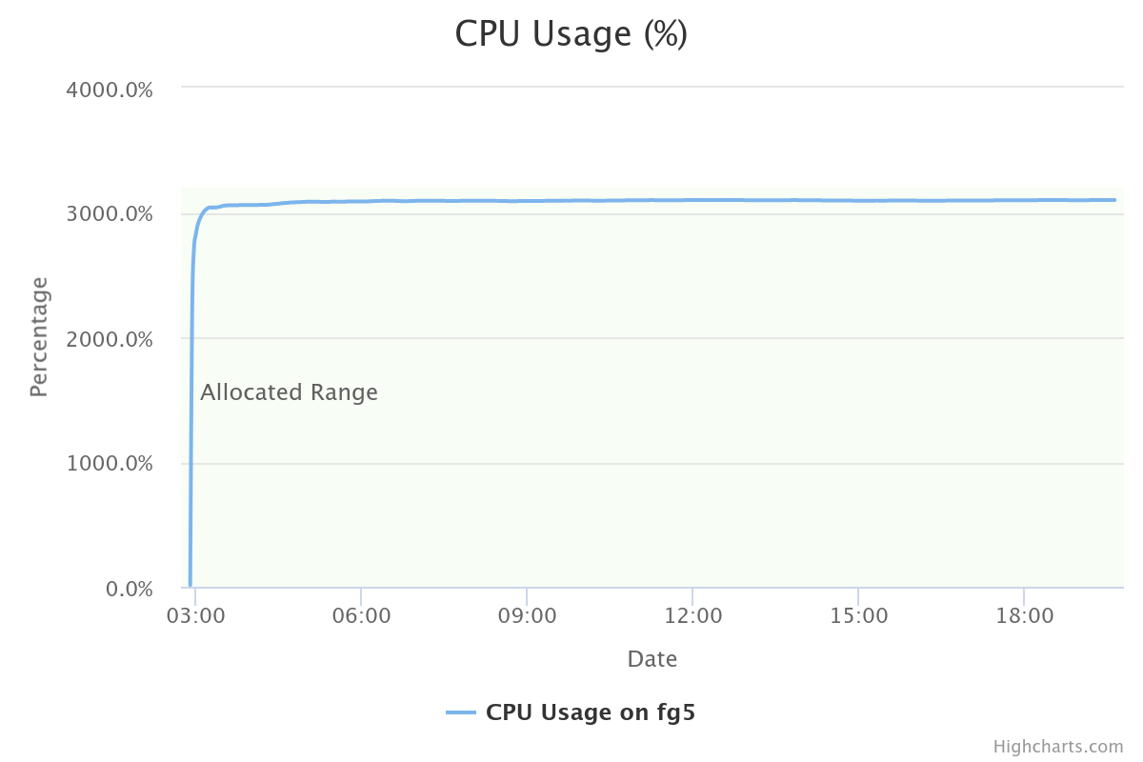

Figure 6. CPU Usage as a Percentage for CNN Model Creation on ARC Cluster. 32 Xeon Gold 6148 cores were allocated. Model creation was conducted on the fg5 node on gpu-v100 of the ARC cluster. Figure was obtained through the Open OnDemand web portal.

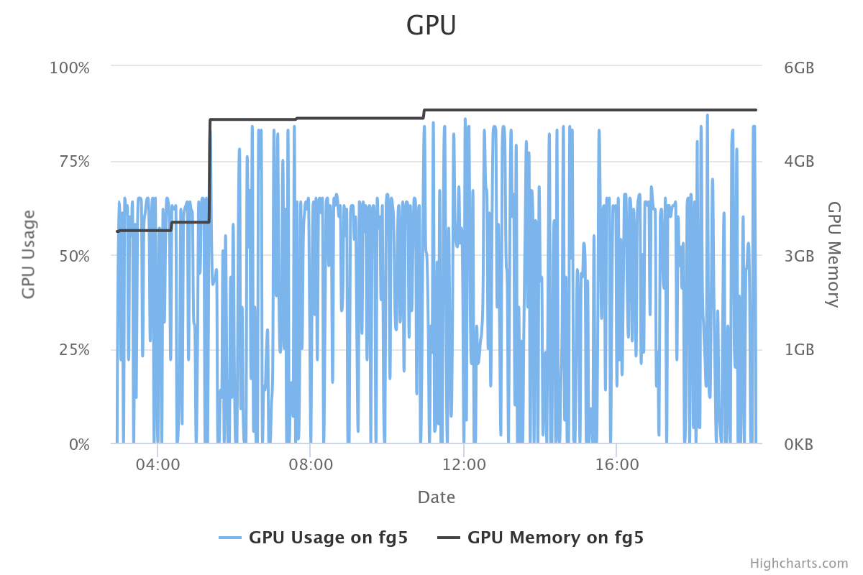

Figure 7. GPU and GPU Memory Usage for CNN Model Creation on ARC Cluster. Two Nvidia Tesla V100 16GB GPUs were allocated. Model creation was conducted on the fg5 node on gpu-v100 of the ARC cluster. Figure was obtained through the Open OnDemand web portal.

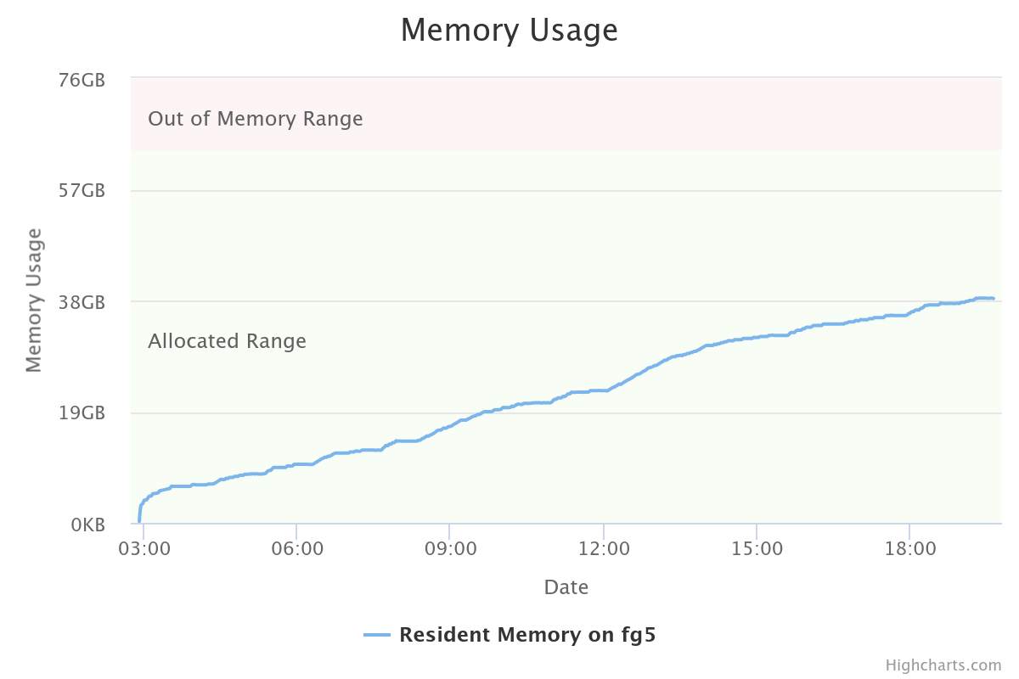

Figure 8. Memory Usage for CNN Model Creation on ARC Cluster. 64.00 GB were allocated. Model creation was conducted on the fg5 node on gpu-v100 of the ARC cluster. Figure was obtained through the Open OnDemand web portal.

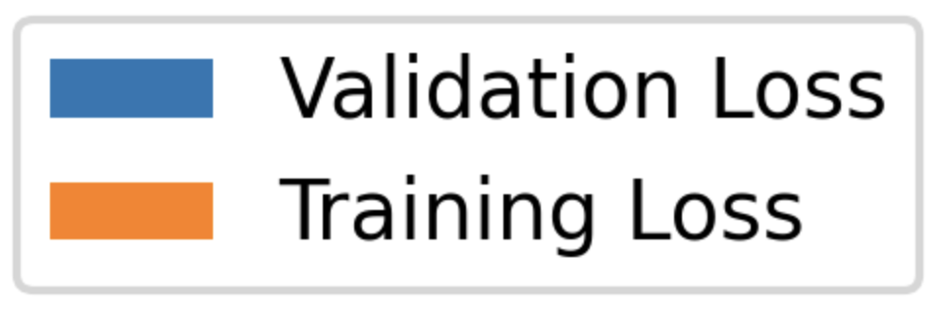

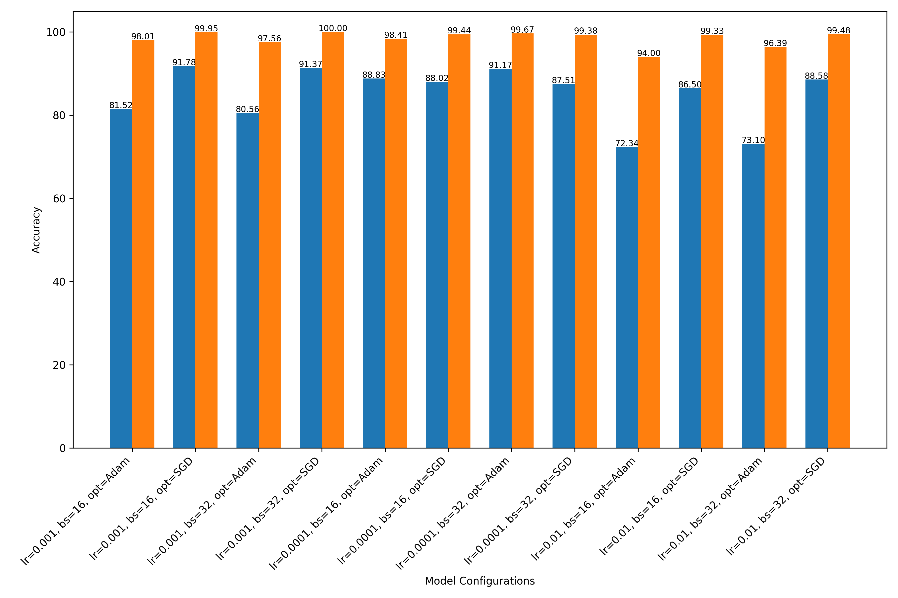Figure 9. Comparison of Training and Validation Accuracy Among Various CNN Architectures with Varied Parameters: Learning Rate (lr), Batch Size (bs), and Optimizer (opt)





Figure 10. Comparison of Training and Validation Loss Among Various CNN Architectures with Varied Parameters: Learning Rate (lr), Batch Size (bs), and Optimizer (opt)

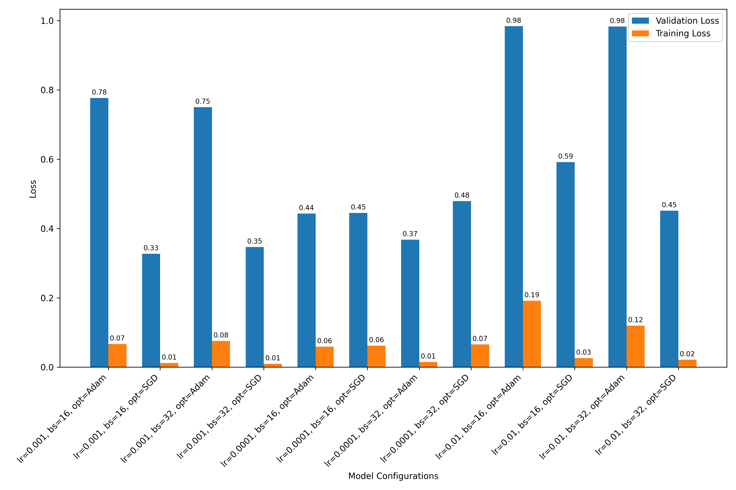

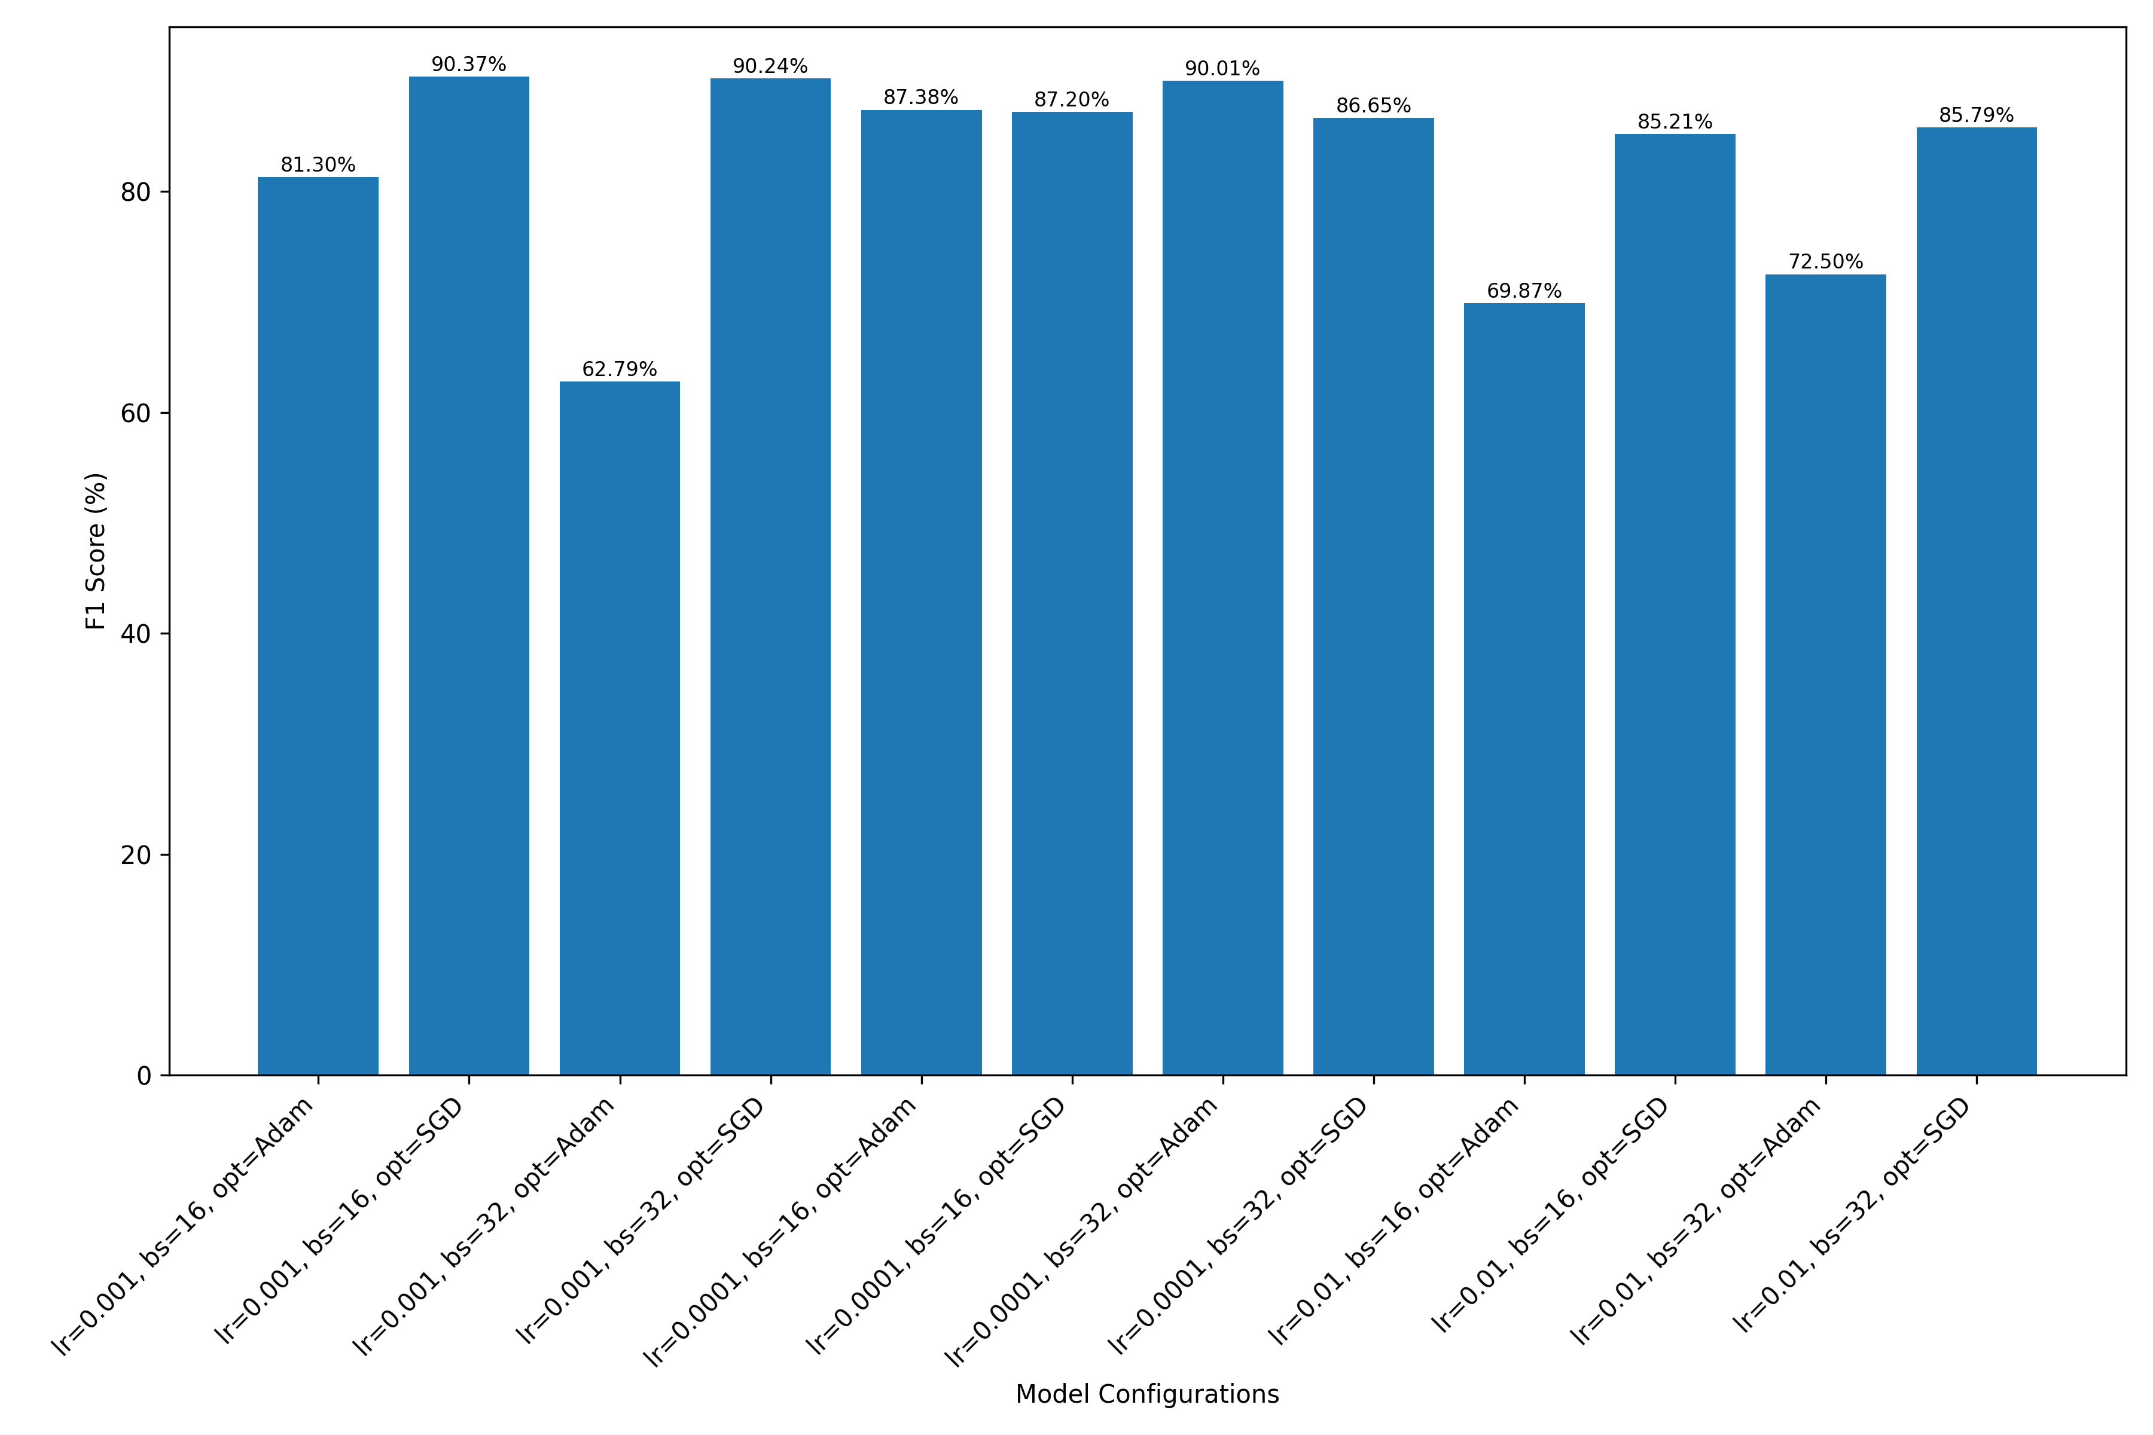

Figure 11. Comparison of Average F1 Scores Among Various CNN Architectures with Varied Parameters: Learning Rate (lr), Batch Size (bs), and Optimizer (opt)

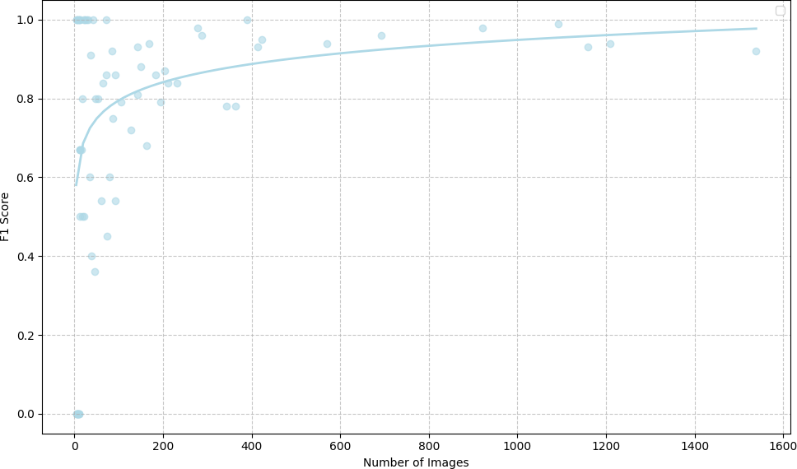

Figure 12. F1 Score Per Species as a Function of the Number of Images of Each Species Present in our Image Dataset Using a Logarithmic Fit Based on our CNN Model with Learning Rate of 0.001, Batch Size of 16, and using the SGD Optimizer (lr=0.001_bs=16_opt=SGD)

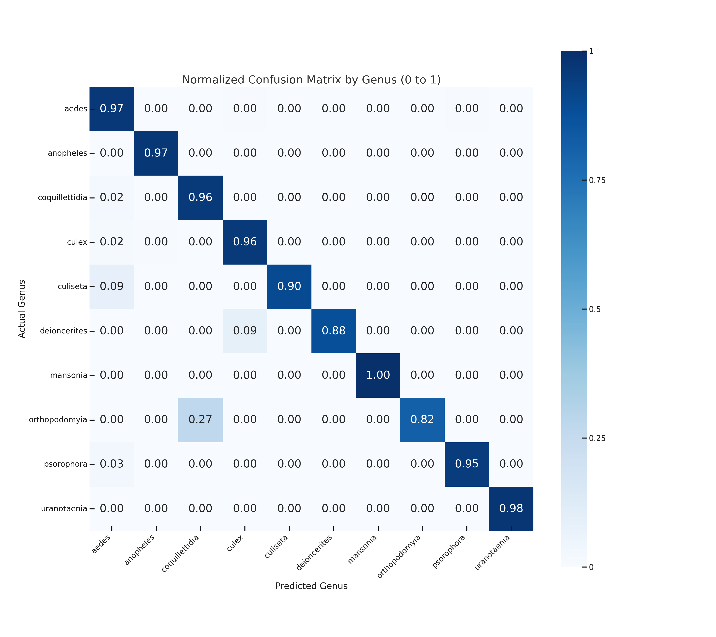



Figure 13. Normalized Confusion Matrix by Genus for CNN Model with Learning Rate of 0.001, Batch Size of 16, and using the SGD Optimizer (lr=0.001_bs=16_opt=SGD)

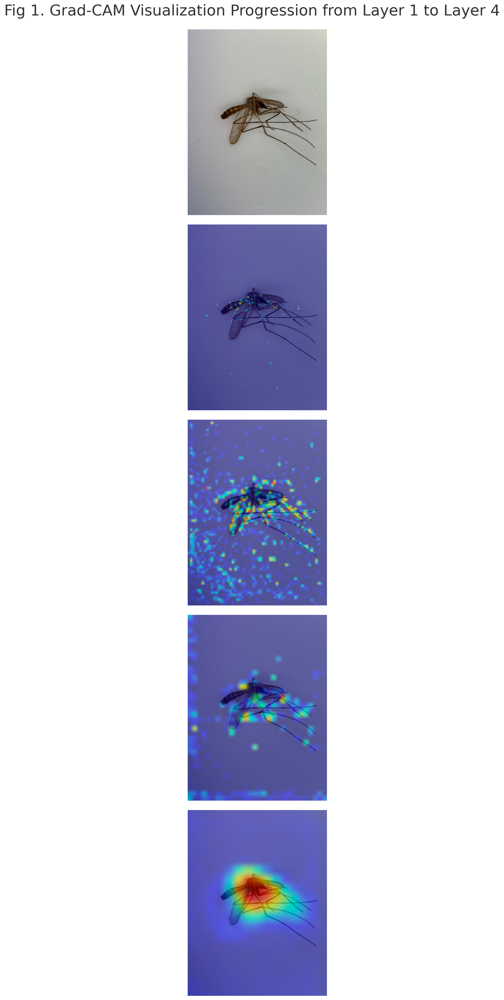

Figure 14. Visualization of Gradient-weighted Class Activation Mappings (Grad-CAM) across Residual Blocks in our CNN Model with Learning Rate of 0.001, Batch Size of 16, and using the SGD Optimizer (lr=0.001_bs=16_opt=SGD) with a ResNet-50 Architecture for an image of a *Culex pipiens* specimen.

## 10.2) Tables

Table 1. Number of Images Per Species Within the Captured Image Dataset

|  |  |
| --- | --- |
| Species | Image Count |
| *Aedes excrucians* | 13 |
| *Culex restuans* | 13 |
| *Aedes melanimon* | 17 |
| *Aedes pullatus* | 8 |
| *Culiseta inornata* | 18 |
| *Culex pipiens* | 36 |
| *Aedes cinereus* | 12 |
| *Culex tarsalis* | 34 |

Table 2. Number of Images Per Genus Within the Combined Mosquito Image Dataset

|  |  |
| --- | --- |
| Genus | Image Count |
| *Anopheles* | 3955 |
| *Mansonia* | 93 |
| *Culiseta* | 114 |
| *Orthopodomyia* | 18 |
| *Coquillettidia* | 204 |
| *Uranotaenia* | 10 |
| *Aedes* | 4845 |
| *Culex* | 2366 |
| *Deinocerites* | 111 |
| *Psorophora* | 1412 |

Table 3. Number of Images Per Species Within the Combined Mosquito Image Dataset

|  |  |
| --- | --- |
| Species | Image Count |
| *Aedes aegypti* | 921 |
| *Aedes albopictus* | 692 |
| *Aedes atlanticus* | 80 |
| *Aedes canadensis* | 128 |
| *Aedes cantator* | 8 |
| *Aedes cinereus* | 12 |
| *Aedes condolescens* | 10 |
| *Aedes dorsalis* | 288 |
| *Aedes excrucians* | 13 |
| *Aedes fairfax* | 6 |
| *Aedes flavescens* | 72 |
| *Aedes hendersoni* | 16 |
| *Aedes infirmatus* | 106 |
| *Aedes japonicus* | 1093 |
| *Aedes mediovittatus* | 84 |
| *Aedes melanimon* | 37 |
| *Aedes nigromaculis* | 42 |
| *Aedes pullatus* | 8 |
| *Aedes sierrensis* | 8 |
| *Aedes sollicitans* | 414 |
| *Aedes spilotus* | 4 |
| *Aedes sticticus* | 4 |
| *Aedes taeniorhynchus* | 184 |
| *Aedes tortilis* | 21 |
| *Aedes triseriatus* | 87 |
| *Aedes trivittatus* | 143 |
| *Aedes vexans* | 364 |
| *Anopheles cf-coustani* | 21 |
| *Anopheles coustani* | 142 |
| *Anopheles crucians* | 278 |
| *Anopheles freeborni* | 570 |
| *Anopheles funestus* | 1210 |
| *Anopheles gambiae* | 1160 |
| *Anopheles maculipalpis* | 30 |
| *Anopheles pharoensis* | 6 |
| *Anopheles pretoriensis* | 12 |
| *Anopheles pseudopunctipennis* | 53 |
| *Anopheles punctipennis* | 212 |
| *Anopheles quadrimaculatus* | 195 |
| *Anopheles rufipes* | 12 |
| *Anopheles squamosus* | 13 |
| *Anopheles tenebrosus* | 6 |
| *Anopheles ziemanni* | 35 |
| *Coquillettidia perturbans* | 204 |
| *Culex antillummagnorum* | 28 |
| *Culex bahamensis* | 4 |
| *Culex coronator* | 61 |
| *Culex erraticus* | 343 |
| *Culex nigripalpus* | 74 |
| *Culex pipiens* | 1539 |
| *Culex restuans* | 93 |
| *Culex salinarius* | 163 |
| *Culex tarsalis* | 48 |
| *Culex territans* | 13 |
| *Culiseta incidens* | 45 |
| *Culiseta inornata* | 64 |
| *Culiseta melanura* | 5 |
| *Deinocerites cancer* | 39 |
| *Deinocerites cuba-1* | 72 |
| *Mansonia titillans* | 93 |
| *Orthopodomyia signifera* | 18 |
| *Psorophora ciliata* | 169 |
| *Psorophora columbiae* | 423 |
| *Psorophora cyanescens* | 390 |
| *Psorophora discolor* | 10 |
| *Psorophora ferox* | 231 |
| *Psorophora howardii* | 17 |
| *Psorophora pygmaea* | 149 |
| *Psorophora signipennis* | 23 |
| *Uranotaenia sapphirina* | 10 |

Table 4. Data Augmentation Techniques Used on the Training Subset of Images

|  |  |  |  |
| --- | --- | --- | --- |
| Data Augmentation Technique | Command Used | Degree/Parameter | Purpose/Effect |
| Resizing | transforms.Resize((224, 224)) | Target Size: (224, 224) pixels | Standardizes image resolution for model optimization and reduces computational load. |
| Random Horizontal Flip | transforms.RandomHorizontalFlip() | Default probability (0.5) | Increases dataset variability by mirroring images horizontally. |
| Random Vertical Flip | transforms.RandomVerticalFlip() | Default probability (0.5) | Enhances dataset diversity by mirroring images vertically. |
| Random Rotation | transforms.RandomRotation(15) | ±15 degrees | Introduces rotational variations to simulate different orientations. |
| Color Jittering | transforms.ColorJitter(brightness=0.2, contrast=0.2, saturation=0.1, hue=0.1) | Brightness, Contrast, Saturation, Hue adjustments | Creates variations in lighting and color conditions. |
| Random Perspective | transforms.RandomPerspective(distortion_scale=0.2, p=0.5) | Distortion scale: 0.2, Probability: 0.5 | Simulates perspective changes to represent different camera angles. |
| Random Affine Transformation | transforms.RandomAffine(degrees=10, translate=(0.1, 0.1), scale=(0.9, 1.1), shear=5) | Degrees: ±10, Translate: 10%, Scale: 90%-110%, Shear: ±5 degrees | Emulates variations in position, size, and shape. |
| Random Grayscale Conversion | transforms.RandomGrayscale(p=0.1) | Probability: 0.1 | Prepares the model for recognizing patterns without color dependency. |
| Gaussian Blur | transforms.GaussianBlur(kernel_size=3) | Kernel Size: 3 | Adds blurring to simulate out-of-focus scenarios. |
| Normalization | transforms.Normalize(mean=[0.485, 0.456, 0.406], std=[0.229, 0.224, 0.225]) | Mean and Standard Deviation for each channel | Standardizes lighting and colors to match pretraining conditions on ImageNet. |

Table 5. Number of Mosquito Images Present within the Training, Validation, and Testing Subset and the Aggregate Total

|  |  |  |
| --- | --- | --- |
| Subset | Number of Images | Percentage |
| Training | 9,188 | 69.63% |
| Validation | 1,970 | 14.93% |
| Testing | 1,970 | 14.93% |
| Total | 13,195 | 100% |

Table 6. Hyperparameter Grid Search Space for Mosquito Species Identification CNN Model

|  |  |
| --- | --- |
| Hyperparameter | Values Explored |
| Batch Size (bs) | 16, 32 |
| Optimizer (opt) | Stochastic Gradient Descent, Adam |
| Learning Rate (lr) | 0.001, 0.0001, 0.01 |

Table 7. Resource Utilization and Runtime Analysis for CNN Model Creation on ARC Cluster

| Job time | CPU | Memory | GPU |
| --- | --- | --- | --- |
| Job ran for 16h 44m | Avg 3,080.7% / 3,200.0%  Max 3,100.0% / 3,200.0% | Avg 22.09 GB / 64.00 GB Max 38.58 GB / 64.00 GB | Avg 40.8% / 200.0%  Max 87.0% / 200.0% |
| 1d requested | 32 CPU cores requested | 64.00 GB requested | 2 GPUs requested |
| 7h 15m unused | 19h 58m CPU time unused |  | 1d 2h 39m GPU time unused |